SYSTEM DESIGN

DATA FLOW DIAGRAMS

DATA FLOW DIAGRAMS:

A graphical tool used to describe and analyze the moment of data through a system manual or automated including the process, stores of data, and delays in the system. Data Flow Diagrams are the central tool and the basis from which other components are developed. The transformation of data from input to output, through processes, may be described logically and independently of the physical components associated with the system. The DFD is also know as a data flow graph or a bubble chart.
DFDs are the model of the proposed system. They clearly should show the requirements on which the new system should be built. Later during design activity this is taken as the basis for drawing the system’s structure charts. The Basic Notation used to create a DFD’s are as follows:

1. Dataflow: Data move in a specific direction from an origin to a destination.

2. Process: People, procedures, or devices that use or produce (Transform) Data. The physical component is not identified.

3. Source: External sources or destination of data, which may be People, programs, organizations or other entities.

4. Data Store: Here data are stored or referenced by a process in the System.

CONTEXT LEVEL DIAGRAM

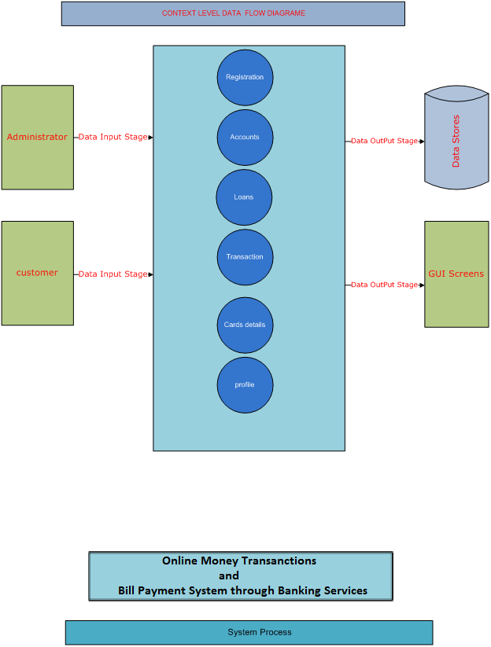

1. ADMINISTRATOR

AUTHENTICATION DFD:
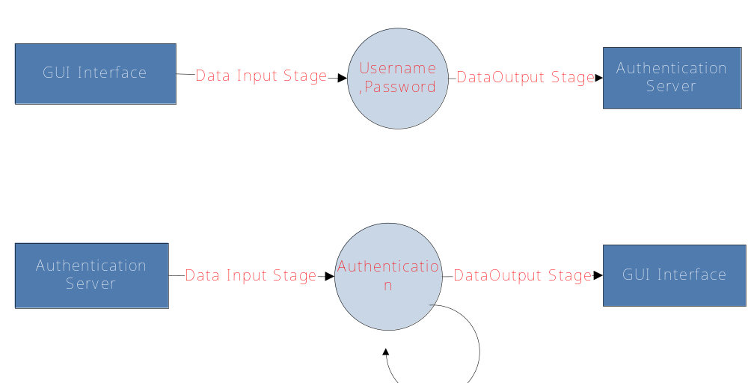

LEVEL-1:

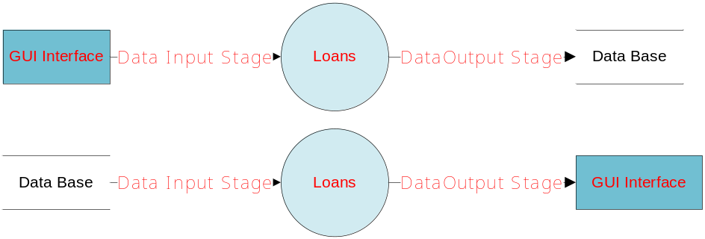

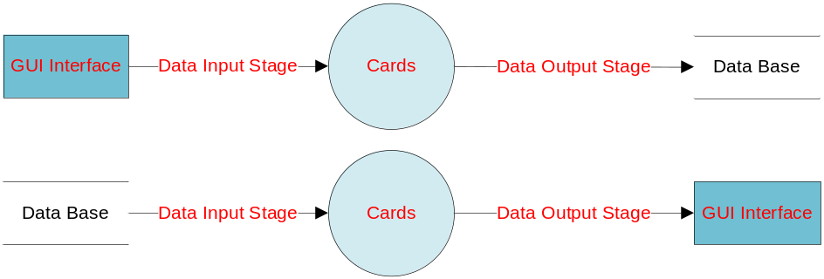

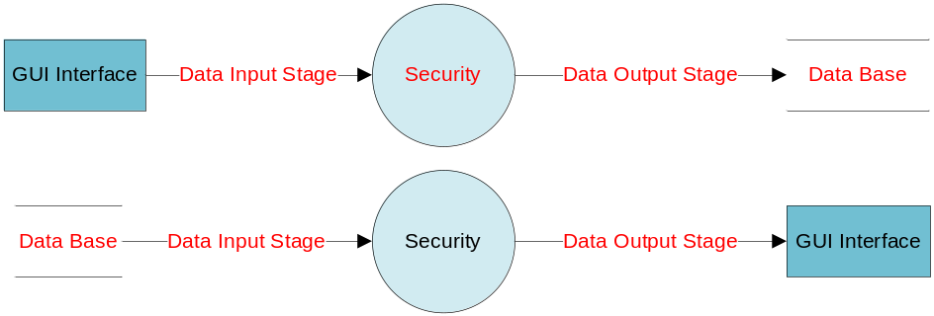

E-R DIAGRAM

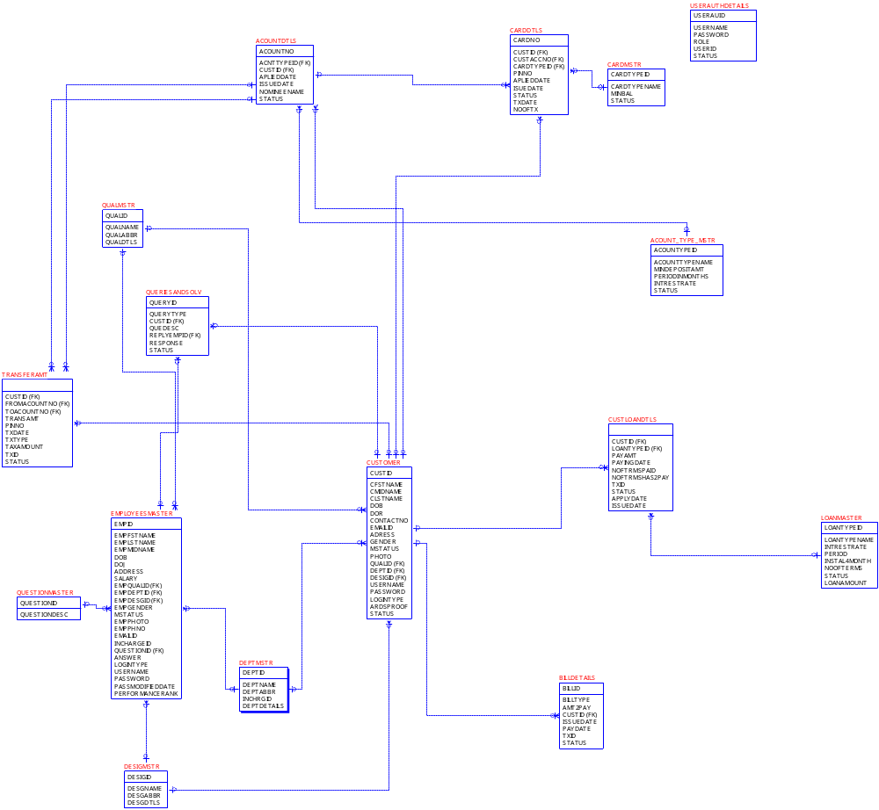

UML DIAGRAMES

USECASE DIAGRAMS

SYSTEM DIAGRAM

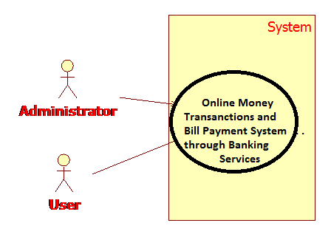

ADMINISTRATOR
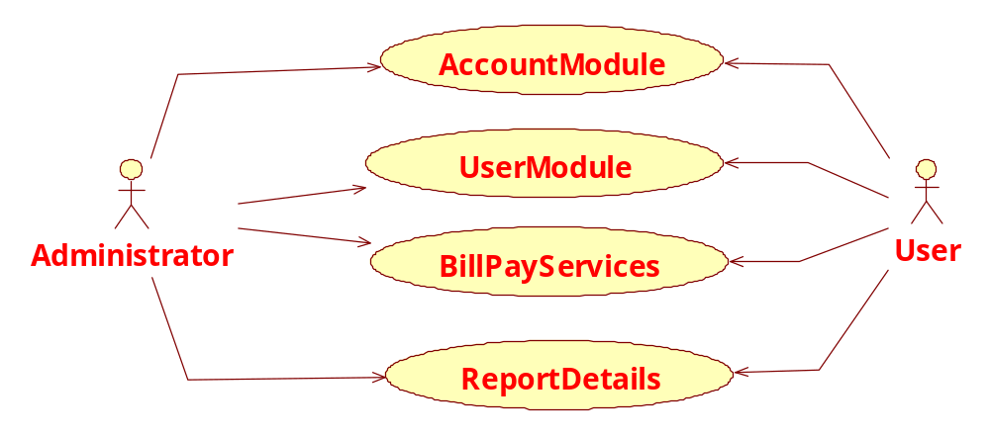

CLASS DIAGRAMS

.

CLASS DIAGRAM
Class diagrams describe the structure of the system in terms of classes and objects. The servlet api class diagram will be as follows.

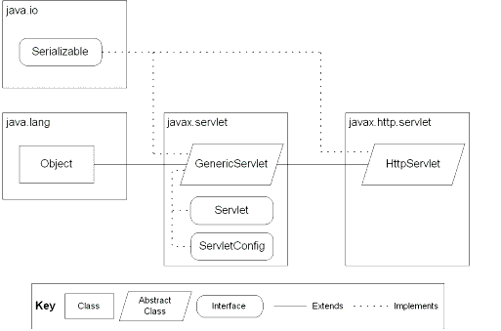
JSP: Implicit Objects

CLASS COLLABORATIVE DIAGRAME

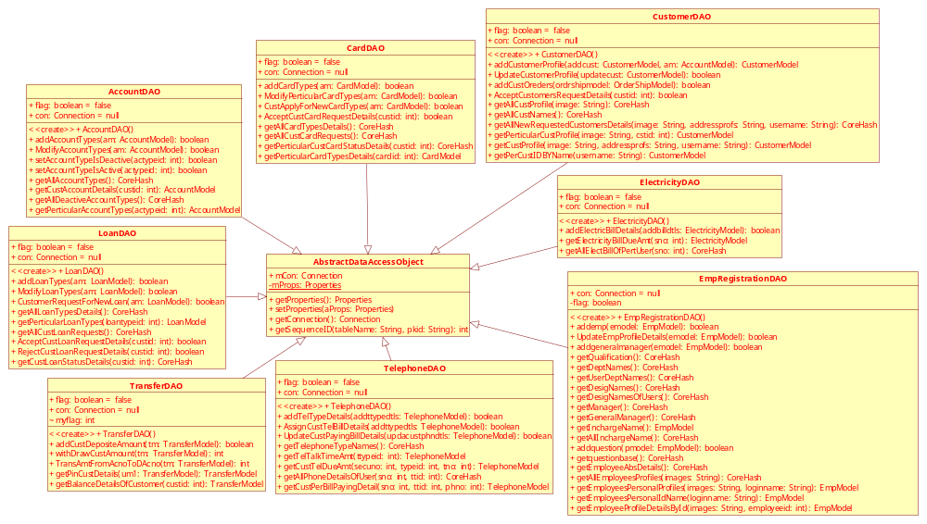

OPERATIONAL SEQUENCE AND COLLABORATION DIAGRAMS

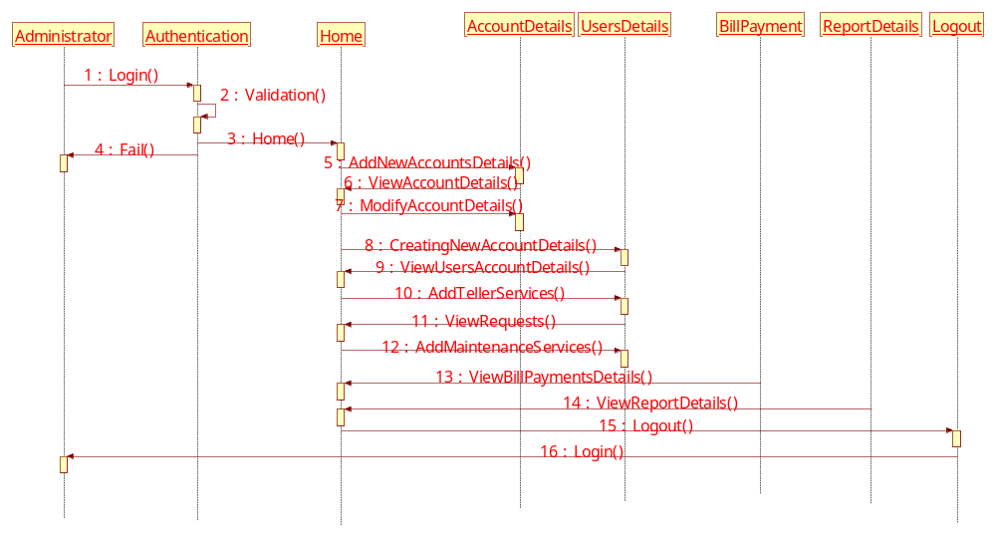

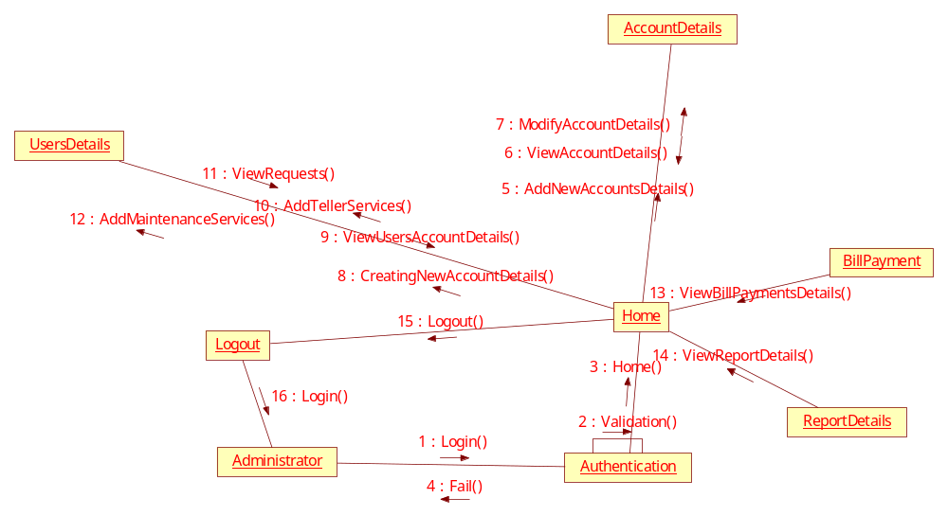
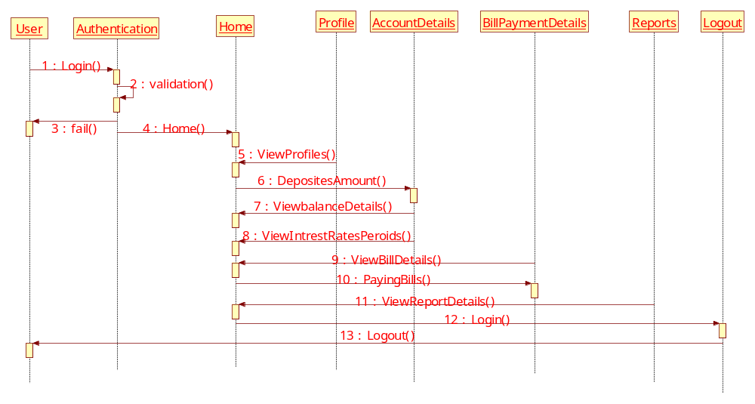

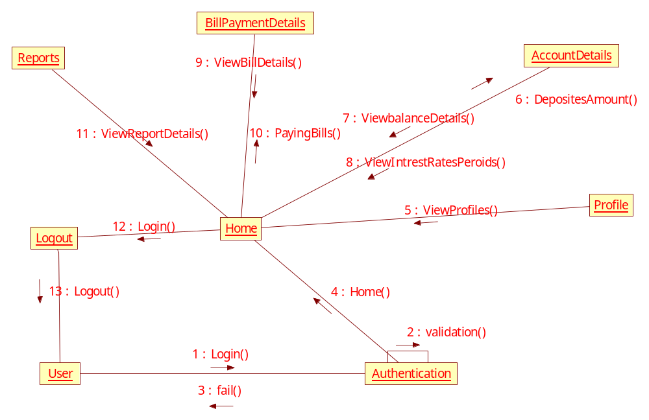

ACTIVITY DIAGRAMS

ADMINISTRATOR
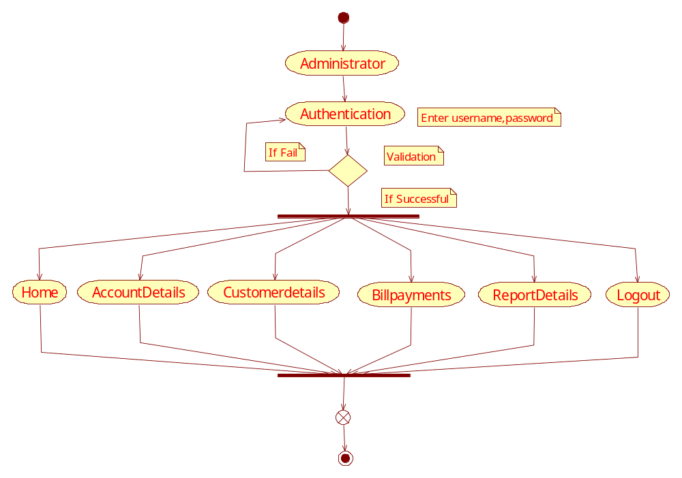

CUSTOMER:
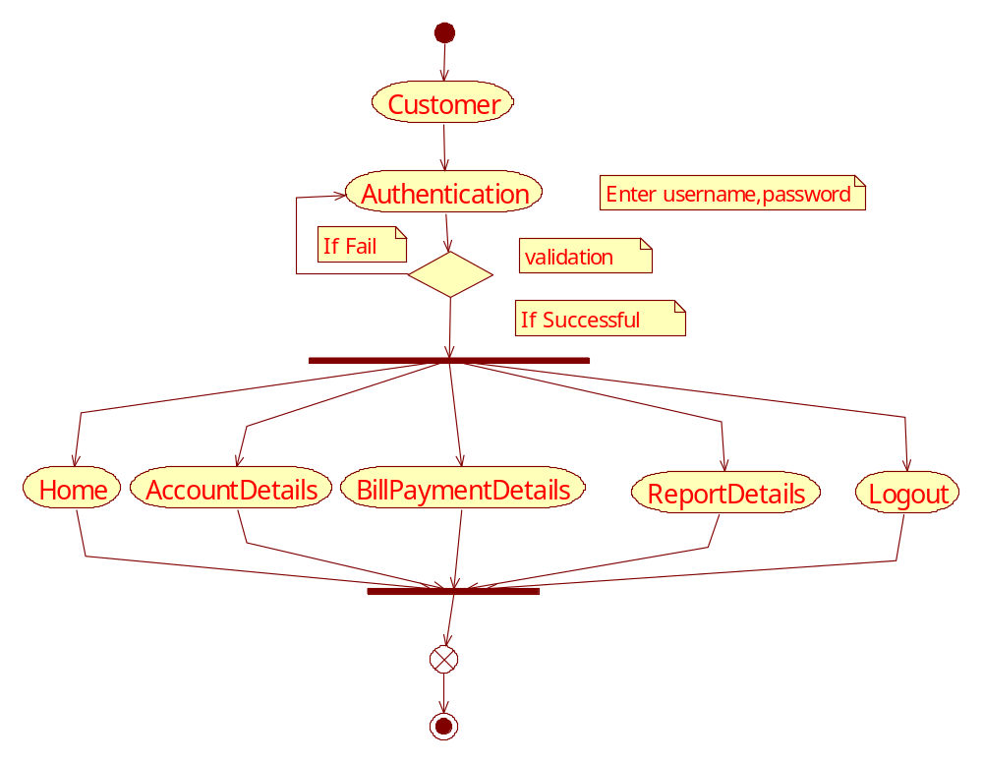

COMPONENT DIAGRAM

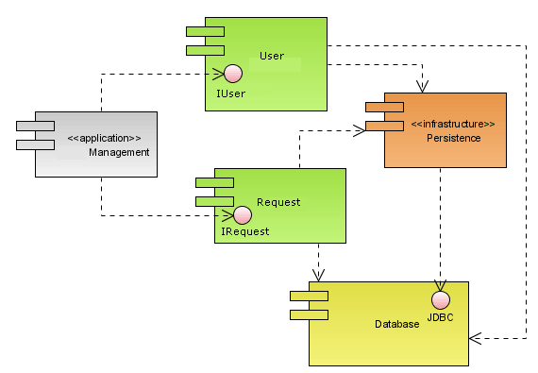

DEPLOYMENT DIAGRAMS

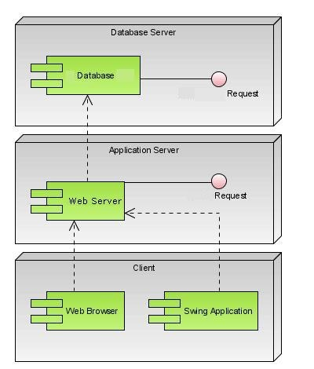

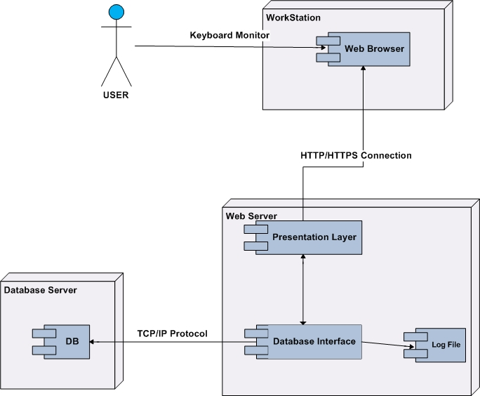

DATA DICTIONARY

ACOUNTDTLS

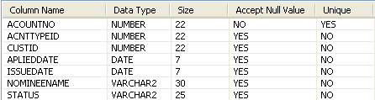
ACOUNT_TYPE_MSTR
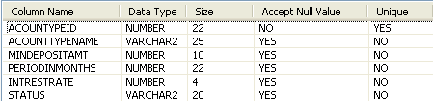
BILLDETAILS
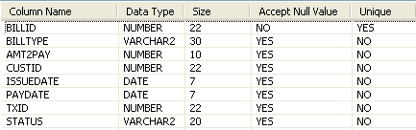
CARDAPPLINGDTLS
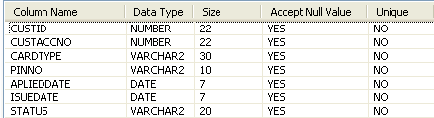

CUSTLOANDTLS
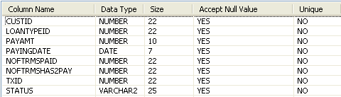
CUSTOMER
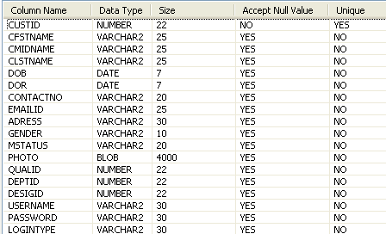
DEPTMSTR
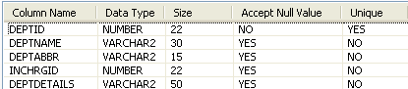
DESIGMSTR
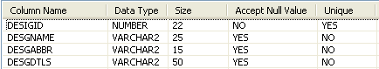

EMPLOYEESMASTER
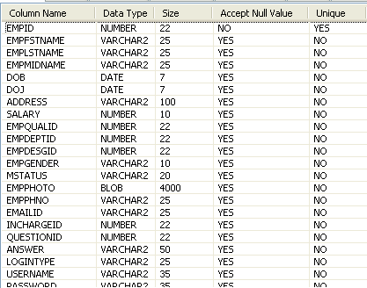
LOANMASTER
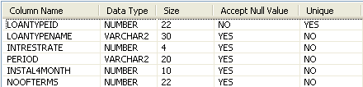
QUALMSTR
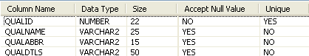
QUERIESANDSOLV
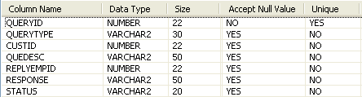

QUESTIONMASTER
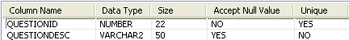
TRANSFERAMT
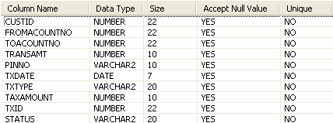
USERAUTHDETAILS
